NAME: AMALEMBA VICTOR

REGISTRATION NO. SCCI/03853P

COURSE: BACHELOR OF TECHNOLOGY IN COMPUTER TECHNOLOGY

UNIT: SOFWARE DEVELOPMENT

ASSIGNMENT TWO: CLIMATE CHANGE TREE PLANTING SYTEM

**Introduction**

The effects of climate change are altering lifestyles across the globe, particularly those of indigenous rural communities in remote areas. However, with the recognition and knowledge critical management plans are required to address the menace.

**The Main objective of the Tree planting System**

1. Register users who want to contribute to the purification of the air by planting trees.
2. Register the trees varieties to mitigate the climate change
3. Provide data for monitoring and surveillance on the progress of the trees
4. Provide accurate data for the management and formulation of policies on environmental pollution

The methodology that the system will adopt shall be the waterfall methodology

Gather system/ project requirements

This shall be performed by undertaking the interview with farmers on the ground to get to understand the problem of disruptive climate change   
2. Perform analysis from the gathered requirements

Upon gathering the requirement the system analyst will be tasked to undertake analysis and reviews of the plants suggested by the farmers on their appropriateness and climatic conditions   
3. Design the system

Different plant varieties will be mapped on the place in order to succeed with the project   
4. Implement the system (codding starts here)  
5. Test the code

Upon developing the system the system analyst will test the code to ensure that it meets the required specifications as given by the farmers   
6. Deploy and maintain the system

The system will be implemented as per the modules   
(CD/CI Continous deployment/ Contious Integration)

**Context Diagram of the Tree Planting Management system**

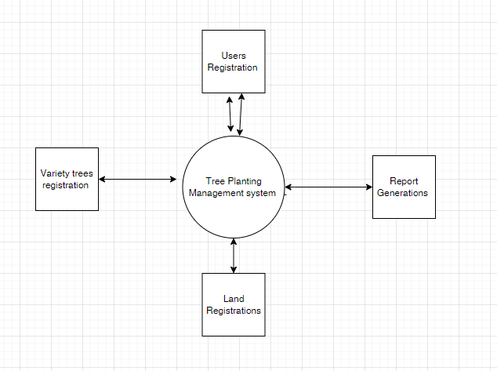

Tree planting management system Interactive Model

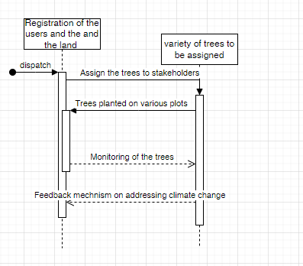

Tree planting management system Structural Model

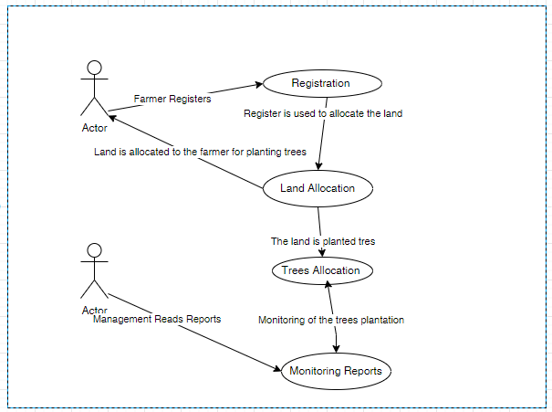

Behavioral Model

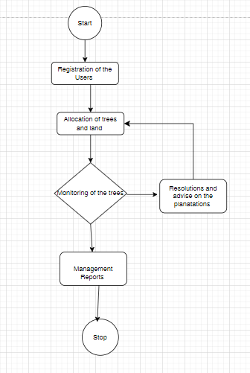

**Modules of Tree Management System**

The system is made of a combination of modules that work in collaboration with each other and make it beneficial to accomplish the main aim of the system.

**Manager Assignment:**

The manager is the person who handles the working around the place given with command over the users to plant the trees carefully. He ensures the care of the plants and the completion of the task. He is assigned by the admin.

**Progress Monitoring:**

The progress of the plantation at a site is given by the report by managers they upload pics of the planted trees area to the interface of the progress monitoring. The values about that will be written by him at the interface. This will be analyzed by the admin.

**Plants Allotment:**

The allotment of the plants to managers decides by the admin on the basis of site and plant condition of the best-suited site and climate. He allows him as many numbers of plants as the sites require to cover the barren area.